**Screen-shot of the Program output:**

**Program 1: DWT Transform**

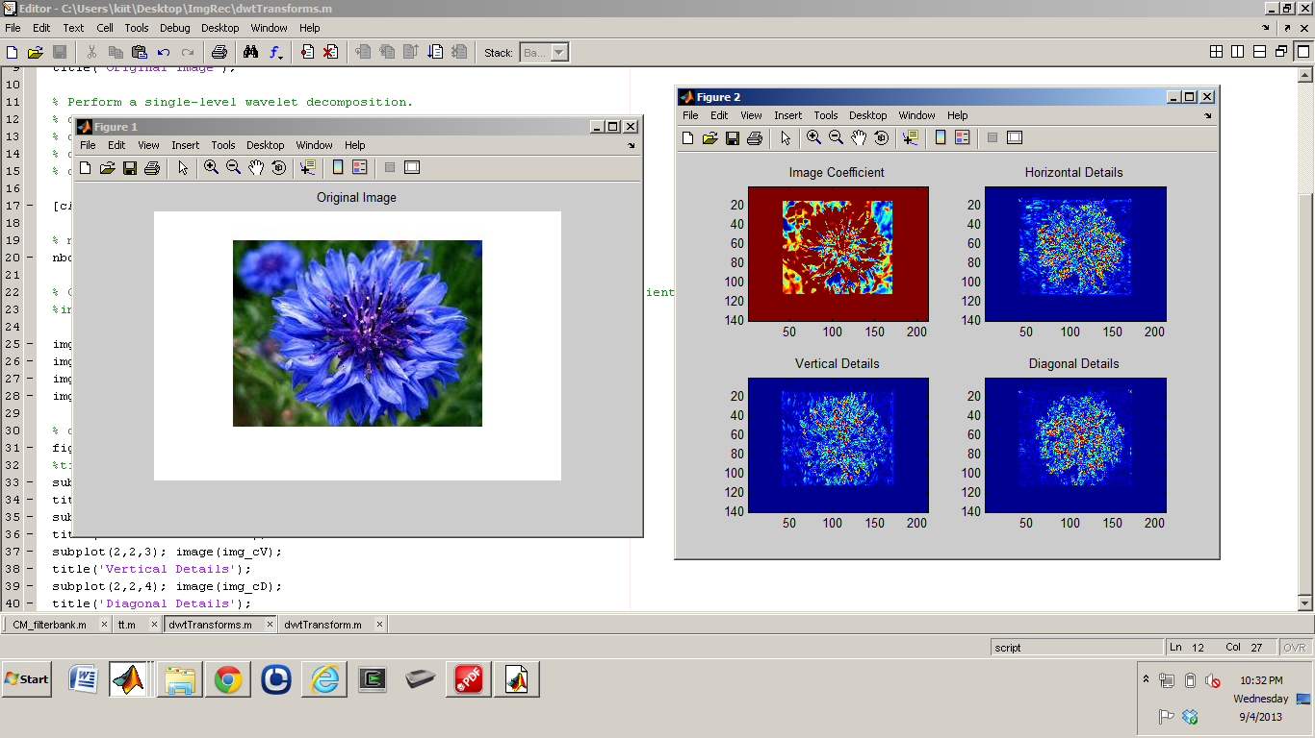

**Program 2: Correlation coefficient of the two images: original image and test image**

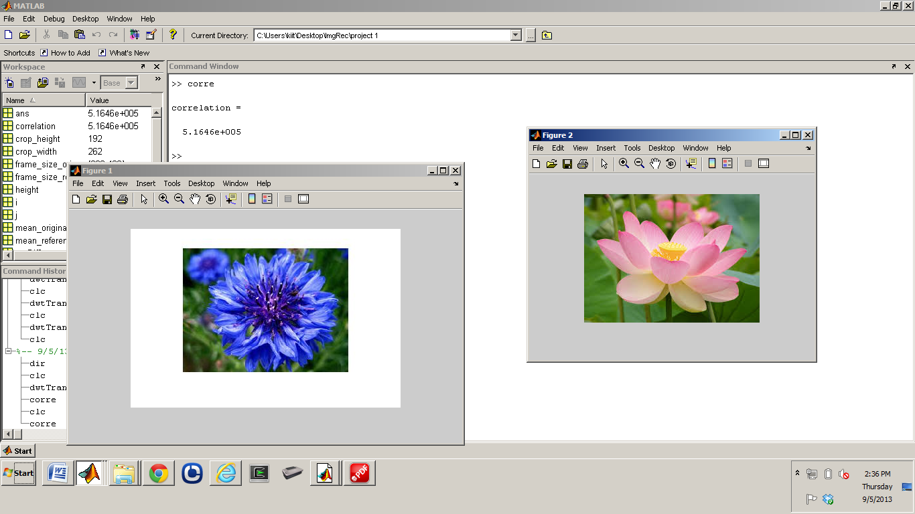

Program 1: DWT Transform

Run dwtTransforms.m file

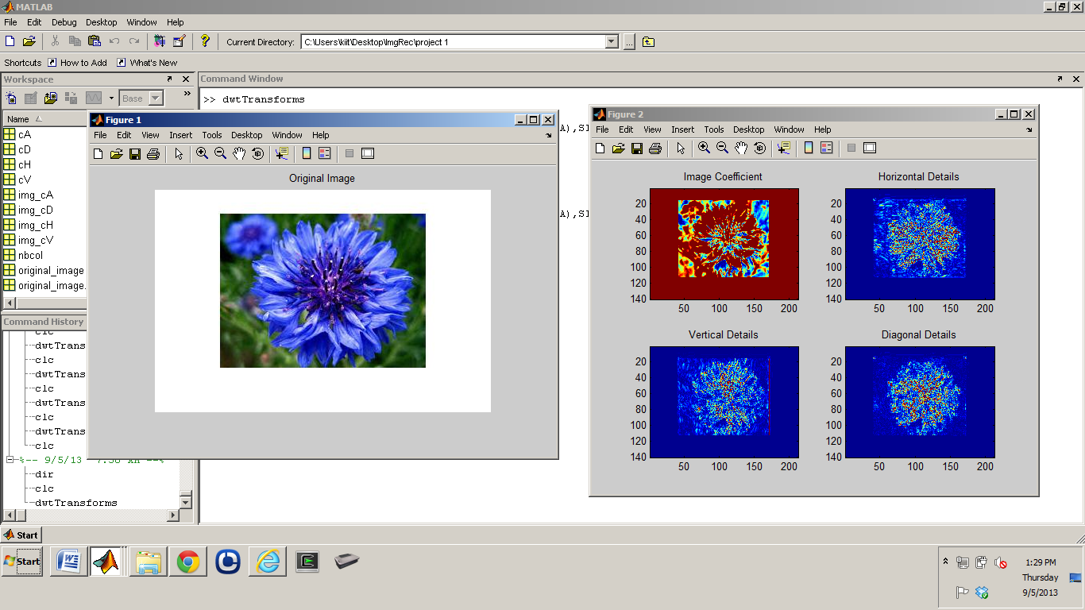

**Code**

**dwtTransforms.m**

clear all

original_image = imread('original_image.jpg');

original_image_grayScale = rgb2gray(original_image); % convert image to greyscale

%whos

figure(1);

imshow(original_image);

title('Original Image');

% Perform a single-level wavelet decomposition.

% cA = coefficients matrix

% cH = horizontal coefficients matrix

% cV = vertical coefficients matrix

% cD = diagonal coefficients matrix

[cA,cH,cV,cD] = dwt2(original_image,'db1');

% map contains the loaded colormap of the input image

nbcol = size(original_image,1);

% Construct the one-level approximations and display details from the coefficients

%img_X = wcodemat(original_image_grayScale,nbcol);

img_cA = wcodemat(cA,nbcol);

img_cH = wcodemat(cH,nbcol);

img_cV = wcodemat(cV,nbcol);

img_cD = wcodemat(cD,nbcol);

% display

figure(2);

%title('1-level Discrete Wevelet Transform Original Image');

subplot(2,2,1); image(img_cA);

title('Image Coefficient');

subplot(2,2,2); image(img_cH);

title('Horizontal Details');

subplot(2,2,3); image(img_cV);

title('Vertical Details');

subplot(2,2,4); image(img_cD);

title('Diagonal Details');

Program 2: Correlation coefficient of the two images: original image and test image



**Code**

**corre.m**

clear all

original_image = imread('original_image.jpg');

original_image_grayScale = rgb2gray(original_image); % convert image to greyscale

mean_original_image = mean(original_image_grayScale(:));

reference_image = imread('test_image.jpg');

reference_image_grayScale = rgb2gray(reference_image); % convert image to greyscale

mean_reference_image = mean(reference_image_grayScale(:));

% -- set frame size variables -----

frame_size_original_image = size(original_image_grayScale);

width = frame_size_original_image(2); % 259

height = frame_size_original_image(1); % 194

frame_size_reference_image = size(reference_image_grayScale);

crop_width = frame_size_reference_image(2); % 259

crop_height = frame_size_reference_image(1); % 194

%%%%%%%%%%%%%%%%%

for i = 1:crop_height

for j = 1:crop_width

refDiffUpper(i,j) = reference_image_grayScale(i,j) - mean_reference_image;

refDiffLower(i,j) = (reference_image_grayScale(i,j) - mean_reference_image)^2;

end

end

refDiffUpper1 = sum(refDiffUpper(:));

refDiffLower1 = sum(refDiffLower(:));

refDiffLower2 = sqrt(refDiffLower1(:));

for i = 1:height

for j = 1:width

orgDiffUpper(i,j) = original_image_grayScale(i,j) - mean_original_image;

orgDiffLower(i,j) = (original_image_grayScale(i,j) - mean_original_image)^2;

if orgDiffLower(i,j) <= 0

orgDiffLower(i,j) = 1;

end

end

end

orgDiffUpper1 = sum(orgDiffUpper(:));

orgDiffLower1 = sum(orgDiffLower(:));

orgDiffLower2 = sqrt(orgDiffLower1(:));

% refDiffUpper1;

% refDiffLower1;

% refDiffLower2;

% orgDiffUpper1;

% orgDiffLower1;

% orgDiffLower2;

correlation = (orgDiffUpper1 * refDiffUpper1) / (orgDiffLower2 * refDiffLower2);

correlation

imshow(original_image),figure,imshow(reference_image)